**Problem Statement:**

Write a hive UDF that implements functionality of string concat_ws(string SEP, array). This UDF will accept two arguments, one string and one array of string. It will return a single string where all the elements of the array are separated by the SEP.

**Solution**:

Java Code:

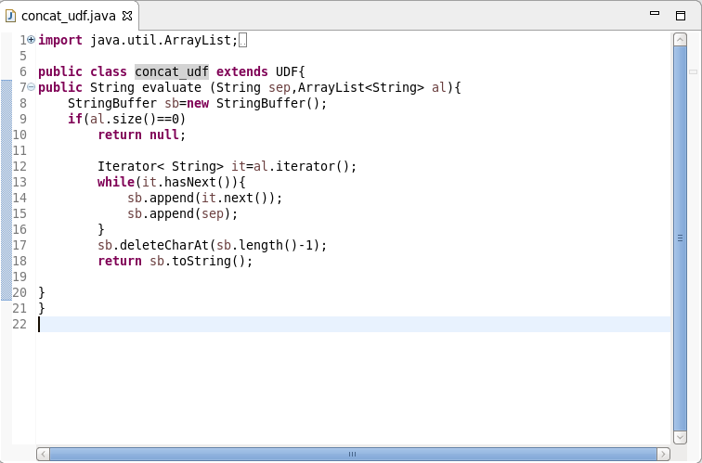

Creating hive table, adding jar and creating temporary function:

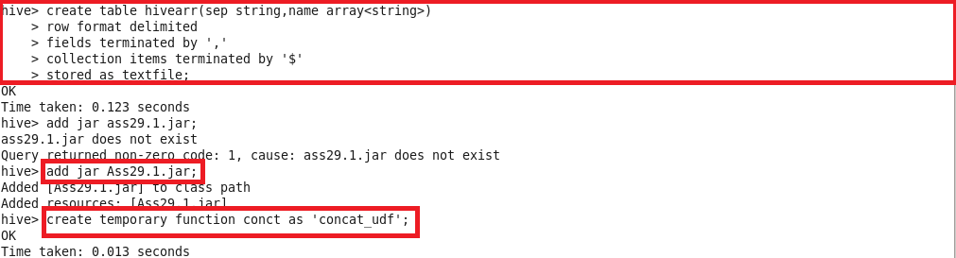

Loading the data into hive table, describing the table contents and using the temporary function:

